In&Out: precision at the highest level

Under the LAUFEN brand umbrella, Alape launched its latest basin “In&Out” in July 2025. In & Out redefines the washbasin: only a small part of the glazed steel basin rim, which is just 3 mm thick, protrudes above the washbasin countertop, while the majority of the basin recess elegantly disappears underneath. This creates an exciting interplay between visible form and concealed function. The innovative design enriches modern bathroom design with a surprising, exciting design highlight - whether in high-quality guest bathrooms or sophisticated restaurant restrooms or hotel lobbies.

A special visual detail is the flush-mounted insert in the basin, which gives the impression that the countertop extends right through the basin. Water can initially collect on the flat surface of the insert and is then gently drained away via a narrow circumferential joint. The insert can be easily removed for convenient cleaning.

Masterful craftmanship in every detail
In&Out conveys the impression of a seamless organic emergence from the countertop -precise, pure and as if cast from a single mould. Instead of predefined material combinations, the focus lies entirely on the exceptional quality and technical finesse of glazed steel. Every line, every surface is designed with meticulous care to achieve a harmonious balance between clarity and extravagance, showcasing the dedication to artisanal mastery and technical perfection.

Perfect balance
This unusual aesthetic is only possible thanks to the production from glazed steel. The extremely thin walls and precise radii lend the basin a special lightness and elegance, while at the same time guaranteeing durability and resilience. The fine, circumferential joint visually separates the basin and washbasin plate without disturbing the flowing overall impression – a perfect balance between form and function.
Yet beyond this dialogue of materials, In&Out embodies a broader sense of balance that extends to the entire bathroom space. In harmony with LAUFEN’s faucets and accessories, it forms part of a complete premium washspace concept where design, technology and artisanal mastery converge seamlessly.
Complementary elements such as designer mirrors and minimal shelving complete a cohesive, elevated bathroom aesthetic.
Tailored personalisation for a holistic bathroom vision
Coherent with the aim of fulfilling the unique vision of its customers — even for the most demanding projects — In&Out offers the possibility to customise the basin in selected parameters, such as rim height or colour scheme. The standard version is available in classic white or in an elegant matt black, allowing for refined aesthetic flexibility.
Beyond highlighting the seamless compatibility with LAUFEN faucets, In & Out embodies a synthesis of precision, artisanal mastery and state-of-the-art technology — all expressed through timeless elegance in a perfectly balanced symbiosis. Together with LAUFEN’s curated accessories, it offers architects and designers the freedom to create integrated, premium bathroom spaces that reflect individual character and a shared passion for design.

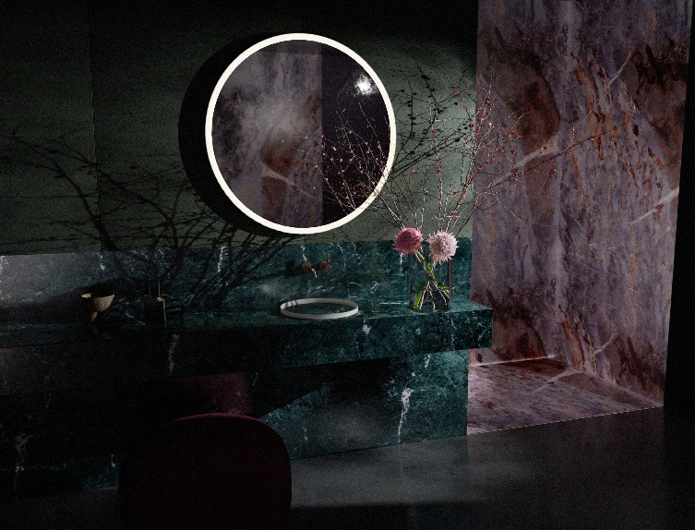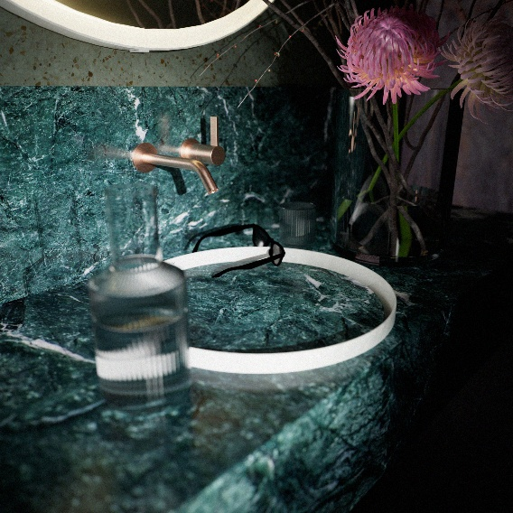
Perfect balance: In&Out seamlessly connects the basin and vanity top with precisely crafted details made of glazed steel.

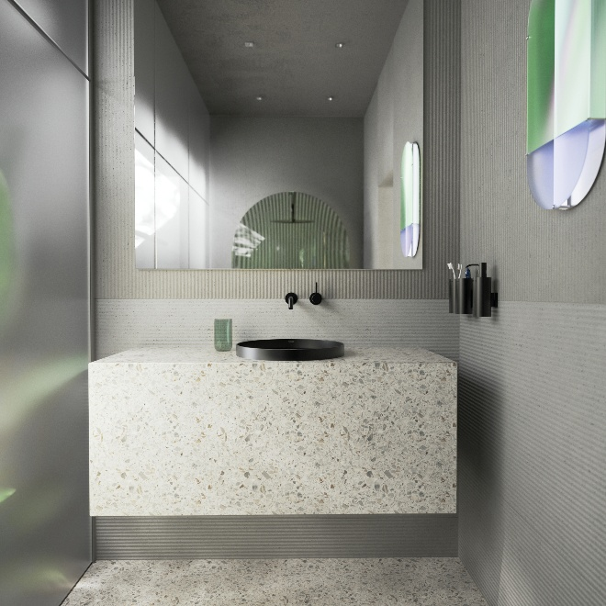 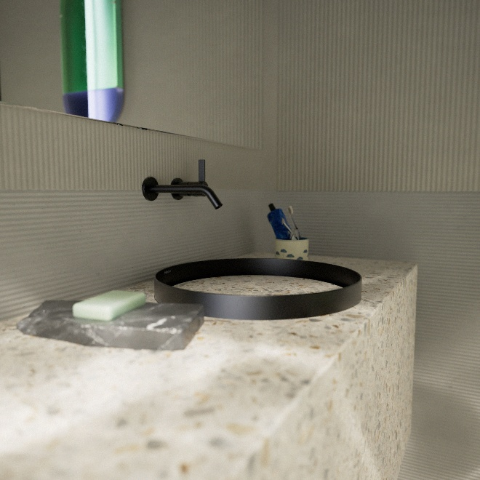
In&Out from LAUFEN x Alape - a design statement that sets new standards in modern bathroom design with its minimal joint and flat shape.

About Alape
Alape was founded in 1896 by Adolf Lamprecht in Penig as a company for enamel products. Today, the company employs around 100 people at two production sites in Goslar and produces aesthetic washbasin solutions. As a manufacturer, Alape stands for technical and functional quality standards and inspiring design. Glazed steel in combination with other high-quality materials enables Alape's individual design for an interior-designed environment. Alape has been part of the Roca Group since October 2023 and is part of the LAUFEN brand umbrella. www.alape.com
alape.com

Press contact:
GeSK
Gabriele von Molitor
alape@gesk.berlin
Tel: +49 30 217 50 460
Alape Marketing
marketing@alape.com
Tel. +49 5321 558-139

About LAUFEN
Since 1892, the Swiss manufacturer LAUFEN has been shaping bathroom experiences through pioneering design, technological innovation, and a deep commitment to sustainability — all supported by a long tradition of Swiss craftsmanship. With its vision of the bathroom as a living space, LAUFEN offers complete solutions that blend functionality with aesthetic refinement, from ceramics and faucets to furniture and accessories. Part of the Roca Group since 1999, LAUFEN reaffirmed its dedication to sustainable production in 2023 by installing the world’s first electric tunnel kiln for sanitary ceramics, achieving zero carbon emissions at its Austrian site in Gmunden.www.laufen.com

LAUFEN Press contact:
monica.garcia@laufen.ch

International Press Office
14 Septembre
marinazanetta@14septembre.com
simonegalli@14septembre.com
Tel. +39 02 35 98 0071

Germany
id pool GmbH
Marc Millenet
laufen@id-pool.de
Tel. +49 15679 237903

